Home Made Bagels

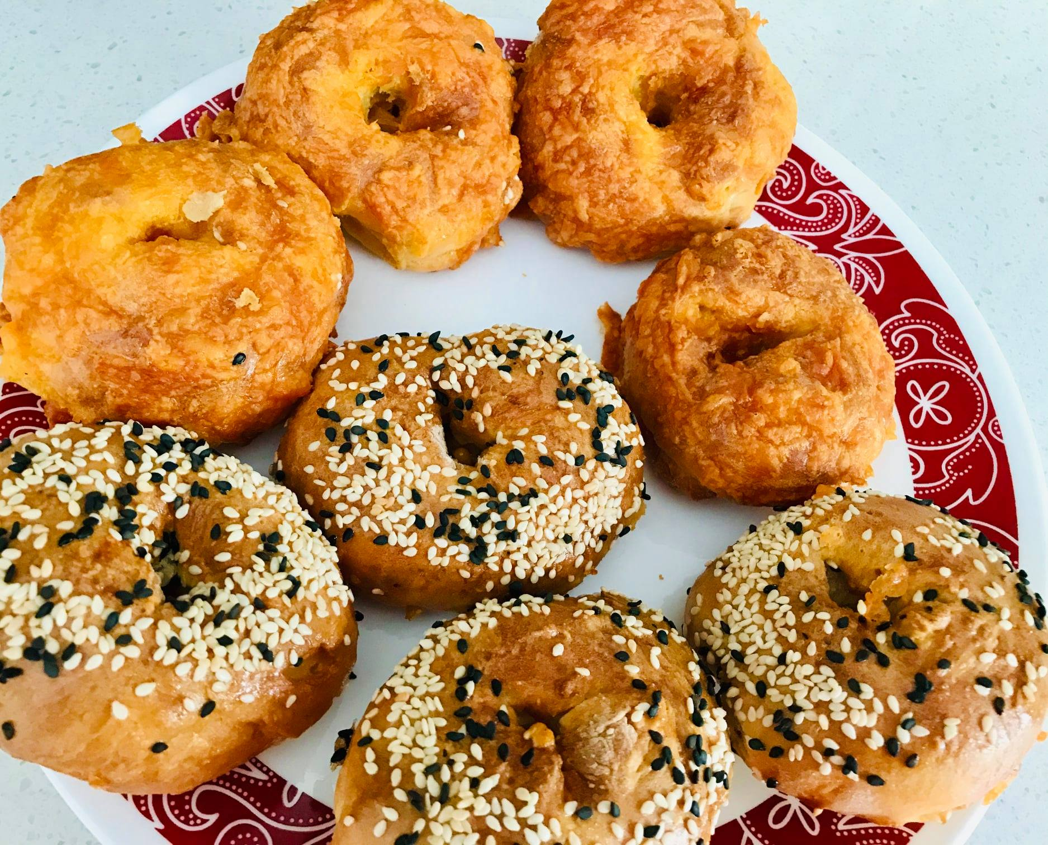

Ingredients

* All-purpose flour 2 cups
* Greek yoghurt 2 cups
* Sugar 1 tbsp
* Baking powder 2 tsp
* Cheddar cheese shredded 2 tbsp or as needed
* White sesame seeds 1 tsp
* Black sesame seeds 1 tsp
* Salt 1 tsp
* Egg 1 beaten

Method

In a bowl, add flour, baking powder, sugar and salt. Whisk to combine. Add yoghurt and knead into a smooth dough with your hands. Place the dough on to a floured surface and divide into 8 parts. Roll and shape them into thick rope and join the two ends to form the bagel shape.  With a brush, coat the bagels with egg and then sprinkle sesame seeds on top. For cheese bagels, sprinkle cheese on top or add cheese while kneading the dough.

**For Air Fryer method,** turn on the air fryer to bake option at 350 deg F for 15 minutes. When preheated, grease the air fryer tray with cooking spray and bake.

**For conventional oven method**, preheat oven to 400 deg F. Arrange bagels on a flat baking tray and bake for about 30 minutes or till done.

**Notes:**  
1. Sesame seeds can be replaced with other favorite toppings like poppy seeds, jalapeno peppers, flax seeds or store-bought bagel seasoning mix.  
2. Different brands of air fryers have different settings. Adjust time and temperature accordingly.